**Collision & Collision Domains**

In the networking field, various network devices are utilized for different purposes. Hubs, switches, routers, and other network devices are utilized to perform different tasks within a network infrastructure. In order to analyze the functionality and effectiveness of network devices, various metrics, defined as standards or systems of measurement, are used. The Collision domain is a metric used in networking.

**Collision in Networks:**

* **Definition:** A collision occurs when two or more devices attempt to transmit data over the same shared medium (e.g., a cable or wireless channel) at the same time. This causes the data packets to garble each other, rendering them unusable.
* **Impact:** Collisions can significantly degrade network performance by:
  + **Increased retransmissions:** Devices involved in a collision must wait a random time and retransmit their data packets, leading to delays and wasted bandwidth.
  + **Reduced throughput:** The overall data flow slows down due to collisions and retransmissions.
  + **Increased latency:** The time it takes for data packets to reach their destinations increases due to collisions.

**Domains and Collision Domains**

A **Domain** refers to a network that is managed by multiple network devices within a single network, known as network controllers. Mainly domains are classified into two categories, i.e., the Collision-domain and the Broadcast domain.

A **Collision Domain** refers to a specific segment inside a network infrastructure where packet collisions can occur.

In simple words, it is a network segment where only one device can transmit data at a time. If more than one device tries to send data simultaneously, a collision occurs, and data loss can happen. Collisions reduce the efficiency and performance of a network, as devices have to wait and retransmit their data after a random backoff time.

Each port on a hub belongs to the same collision domain. Hence collisions happen often in such an environment. However, each port exists in a bridge, switch, or router in its own separate collision domain.

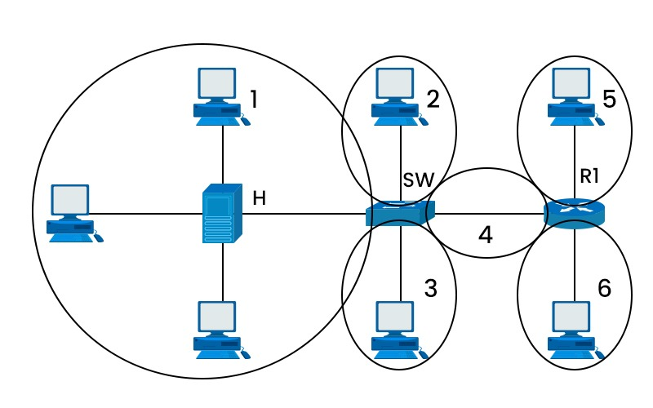

**Common examples:**

* + Early Ethernet networks (10BASE5, 10BASE2) that used shared coaxial cables.
  + Hubs, which simply amplify and repeat signals, creating a single collision domain for all connected devices.
  + Wireless networks, where devices share the same wireless channel, although modern Wi-Fi protocols have mechanisms to mitigate collisions.

**Techniques to Minimize Collisions:**

* **Carrier-Sense Multiple Access with Collision Detection (CSMA/CD)**

This protocol, used in older Ethernet networks, requires devices to listen for other transmissions before sending their own data. If a collision is detected, both devices wait a random time and retransmit. While effective, it can lead to inefficiencies due to wasted bandwidth and idle time.

* **Full-Duplex Communication**

Modern Ethernet networks operate in full-duplex mode, where devices can transmit and receive data simultaneously on separate channels (e.g., using twisted-pair cables or fiber optics). This eliminates collisions within the same collision domain.

* **Switches**

These network devices learn the MAC addresses of connected devices and forward data only to the intended recipient, breaking up large collision domains into smaller, more efficient ones.

* **Wireless Protocols**

Modern Wi-Fi protocols (e.g., IEEE 802.11ac, 802.11ax) employ techniques like Carrier Sense Multiple Access with Collision Avoidance (CSMA/CA) and spatial multiplexing to reduce collisions and improve efficiency in wireless networks.

* **Proper Network Design**

By implementing appropriate network segmentation, using switches effectively, and controlling the number of devices in each collision domain, you can minimize the chances of collisions and optimize network performance.